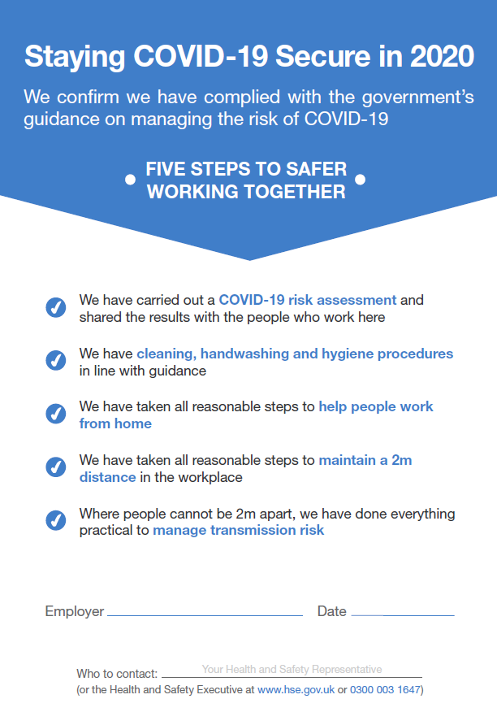

WT Consultancy (SW) Ltd – 01884 675101